|  |
| --- |
| COURSE: DLD LAB |
| DLD – PROJECT PROPOSAL |
| TITLE: **VOICE CONTROLLED BLUETOOTH CAR**  PARTICIPANTS:   1. **MUZAMMIL BIN SOHAIL (22F – 3110)** 2. **AHMAD ZUBAIR (22F - 3161)**   SECTION: **2A1** |

**PROJECT INTRODUCTION:**

We intend to design a voice controlled car that would use the Bluetooth technology to interact with the voice commands of the instructor person, and respectively perform functionalities such as e.g. turning right, moving forward etc.

**COMPONENTS INVOLVED:**

1. Plywood
2. Screws (8)
3. Steel tire holders (4)
4. Motors (4)
5. Tires (4)
6. Wires
7. Pasting strips
8. Battery 12V
9. L298N Module
10. H2 – 05 BT Module
11. Arduino UNO
12. Programming Code for Arduino UNO

**PROJECT DESCRIPTION:**

The car would have four motors attached to four respective tires. The motor would be powered with the 12V Battery. Pasting Strips would be used to properly attach the components to the base of the project i.e. Plywood. Steel tire holders would be attached with the screws so they have a firm grip and could hold onto the rotatable tires. Wires would be used to make connections in between the components. H2 – 05 BT Module allows the enabling of the connectivity to Bluetooth and instructions processing through the mobile phone or some other capable device. Arduino UNO IC consists of components such as crystal oscillator, serial communication, voltage regulator, etc. that would support the microcontroller. Code for Arduino UNO IC would put in the algorithm that would enable the car to know what to do, when to do, and how to do etc. The L298N Module allows speed and direction control of two DC motors at the same time. It can drive DC motors that have voltages between 5V and 35V (in this case 12V).

**PROJECT IMPORTANCE:**

The use of Bluetooth enables wireless communication to the device i.e. Car, which means that the car could move from one location to another by just a voice instruction. It is seen that the vocal commands could be given to the robot via any Bluetooth supported device which makes the process more feasible. In conclusion, productivity level of the machine gets boosted.  The Bluetooth technology in this case also provides a wider range of operational control for the car. Unlike the mechanical mechanism, the input instructions to this car are seen to be given at a faster rate by means of the vocals. Lastly, Operators won't have to rely on a desktop-type environment to relay and receive the information of the car.

**CIRCUIT DIAGRAM:**

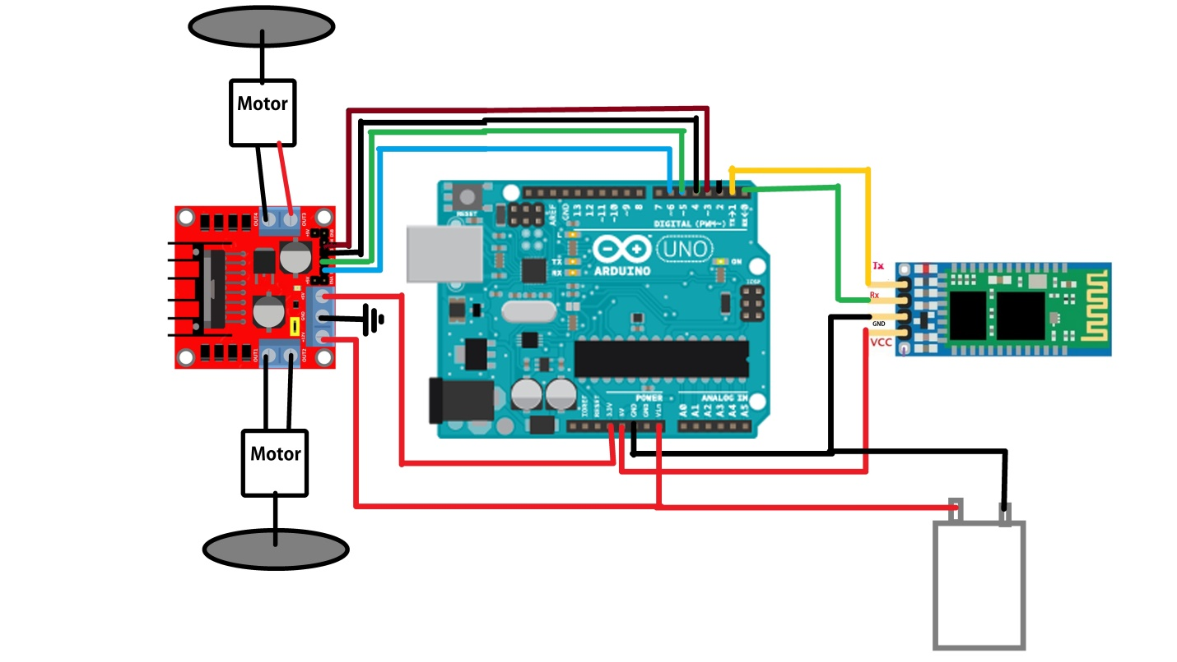

**CONCLUSION:**

The car has total 7 functions embedded into its code involving Forward, Left, Right, Stop, Circular motion etc. The car simply takes input from the BT Module using a supported device, finds its respective algorithm from the code incorporated in the Arduino UNO and then powers the motors from the battery to work in response to the command given.